**Aim**

Implement a queue using an array with the ability to enqueue, dequeue, and display elements.

**Algorithm**

* **Enqueue**:
  + Check if queue is full (rear == max-1). If full, print overflow.
  + Else, increment rear and insert element. If first element, set front = 0.
* **Dequeue**:
  + Check if queue is empty (front == -1 or front > rear). If empty, print underflow.
  + Else, return element at front and increment front.
* **Display**:
  + If empty, print queue empty.
  + Else, print all elements from front to rear.

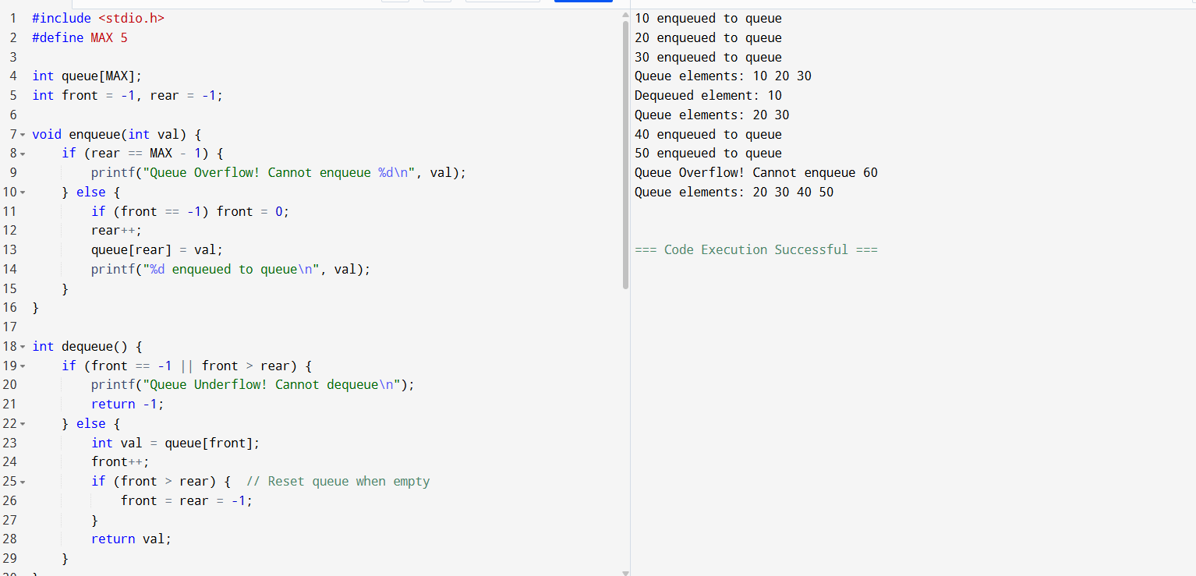

**Sample Output**

10 enqueued to queue

20 enqueued to queue

30 enqueued to queue

Queue elements: 10 20 30

Dequeued element: 10

Queue elements: 20 30

40 enqueued to queue

50 enqueued to queue

Queue Overflow! Cannot enqueue 60

Queue elements: 20 30 40 50